**Store-Analysis-Report:**

**Overview:**

The Store Analysis Report project aims to provide insights into store data using ETL/ELT processes, unsupervised machine learning techniques, and Tableau visualization. The project involves data extraction, transformation, and loading, followed by the application of unsupervised ML algorithms to identify loyal customers. Additionally, it includes the creation of a Tableau dashboard for business insights.

**Project Structure:**

The project follows a Medallion Architecture, organized into the following directories:

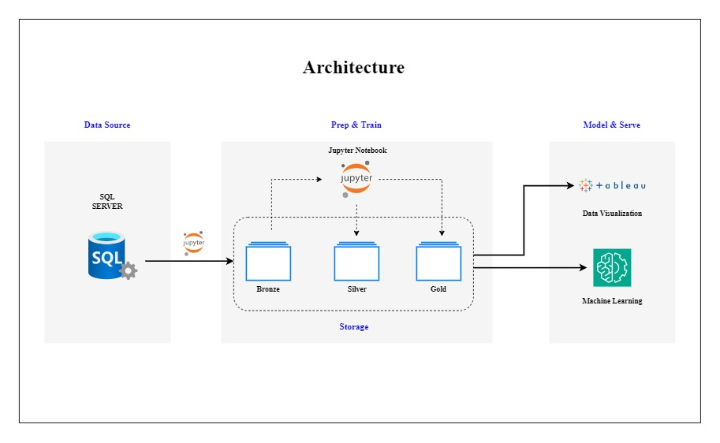

**ETL Process:**

**Data Scrapping:**

Data is extracted from the MS SQL Database using Python scripts.

Raw data is stored in the Data Storage/Bronze folder in parquet format.

**Data Cleaning (Silver):**

Duplicates are treated, missing values are handled, and noise data is checked.

Cleaned data is saved in the Data Storage/Silver folder in parquet format.

**Data Transformation (Gold):**

Further data transformation is performed, resulting in the final format.

Transformed data is saved in the Data Storage/Gold folder in parquet format.

**Machine Learning Algorithm:**

ML algorithms, such as RFM (Recency, Frequency and Monetary) analysis, are applied to identify loyal customers.

Python scripts in the ML_Models folder implement the ML algorithms and group customers based on their behavior.

**Pareto Principle (80/20 Rule)**

Observation: 36% of customers contribute to 61% of business. These is reflect the Pareto rule but we follow Pareto rule to optimize the Business.

**Recommendations:**

Develop a loyalty program for high-value customers.

Offer exclusive deals, discounts, and rewards to retain them.

Implement upselling and cross-selling strategies.

Request referrals from high-value customers and reward them.

**Low RFM Value Customers**

Identification: 1.9 % of customers contribute only not even 1% to the business.

Strategies:

Understand the needs and preferences of these customers.

Tailor products, services, and marketing efforts to meet their specific needs.

Focus on improving their customer experience.

**Tableau Dashboard Insights:**

A Tableau dashboard is created to visualize insights derived from the data analysis.

The Tableau dashboard files are located in the Tableau Dashboard folder. (Image of dashboard is below)

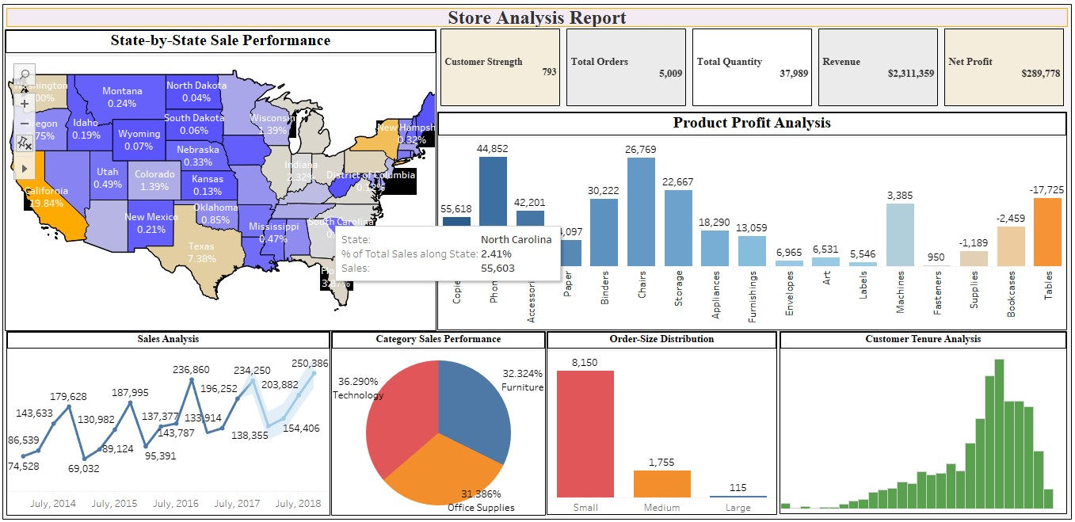

**Customer Strength:**

The business currently boasts a robust customer base of 793 individuals, indicating a strong market presence.

**Total Orders:**

A significant volume of 5009 orders has been processed, showcasing a substantial demand for the products or services.

**Total Quantity Sold:**

The business has successfully moved 37,989 units, underscoring a considerable level of product adoption.

**Revenue:**

Achieving a noteworthy revenue of $2,311,359 highlights the financial success of the business.

**Net Profit:**

With a net profit of $289,778, the business demonstrates a healthy bottom line.

**Regional Sales Analysis:**

Sales are particularly strong in states such as California, New York, Texas, and Washington, while North Dakota and South Dakota exhibit lower sales.

**Sales Forecasting Analysis:**

Utilizing time series forecasting, the business predicts an upward trend in sales from July 2017 to October 2018, with a discernible yearly seasonality.

**Category Sales Distribution:**

The three main categories (Technology, Office Supplies, Furniture) contribute equally to the overall sales, each ranging between 30-35%.

**Customer Tenure Analysis:**

The tenure of customers follows a negative distribution, indicating a varied range of customer relationships.

**Order Size Distribution:**

Small-sized orders dominate the distribution, followed by medium-sized orders, with larger orders being less common.

**Product Profitability Analysis:**

High-profit items include copper, phones, and accessories. Moderate profits are observed in paper, binders, and chairs. However, there are notable losses associated with supplies, bookcases, and tables.

**Business Optimization Suggestions:**

**Target Marketing Efforts:**

Focus marketing campaigns in states with higher sales to maximize reach and impact.

**Supply Chain Efficiency:**

Optimize inventory and supply chain processes to meet the demand reflected in the sales forecast.

**Customer Relationship Management:**

Leverage insights from customer tenure analysis to tailor retention strategies for different customer segments.

**Product Mix Adjustment:**

Evaluate the profitability of products and consider adjusting the product mix to emphasize high-profit items and reduce reliance on less profitable products.

**Promotional Strategies:**

Implement targeted promotions or discounts on categories with lower sales to stimulate customer interest and drive sales.

**Order Size Promotion:**

Introduce incentives or promotions to encourage larger order sizes and increase overall transaction value.

**Cost Management:**

Explore cost reduction strategies for products with high losses, ensuring a more sustainable profit margin.